Customized Catering--On and Off Premise
Hege’s is a casual, welcoming French Bistro where you’ll experience the same gracious hospitality as the coastal gentry of Kiawah and Seabrook Islands. No foams. No froths. Just respect for the ingredients, the season, and time and talent in the kitchen. For classic
French and international cuisine in a casual, inviting atmosphere, visit Hege’s Restaurant.
Offering dinner six days a week, Hege’s menu features fresh seasonal products prepared with classical sauces.
In addition to the restaurant and bar, Hege’s has both private and semi-private dining rooms which provide the perfect setting for cocktail parties, rehearsal dinners, business functions, and charity events. Extensive catering options are now available to assist you in planning your next
“House Party.”
We want customers to enjoy the luxurious experience in the comfort of their own homes.
Hege’s of Freshfields Village is known for our diverse menu options and impressive cuisine. We personalize your experience from menu design and planning to seamless execution. Allow Hege’s to customize a unique catering menu for you and your guests, whether it be large or small, formal or casual, private or corporate, Hege’s will offer a convenient alternative to traditional cocktail parties, dinners or luncheons.

Rehearsal Dinners
•••
Wedding Receptions
•••
Cocktail Parties
•••
Special Events: Anniversaries, Holiday and Birthday Parties
•••
Corporate Parties
•••
Brunch
•••

In Home Catering
Hege’s offers pick-up or delivery platters already perfectly prepared for you and your guests or we can prepare a customized menu to fulfill your culinary desires.

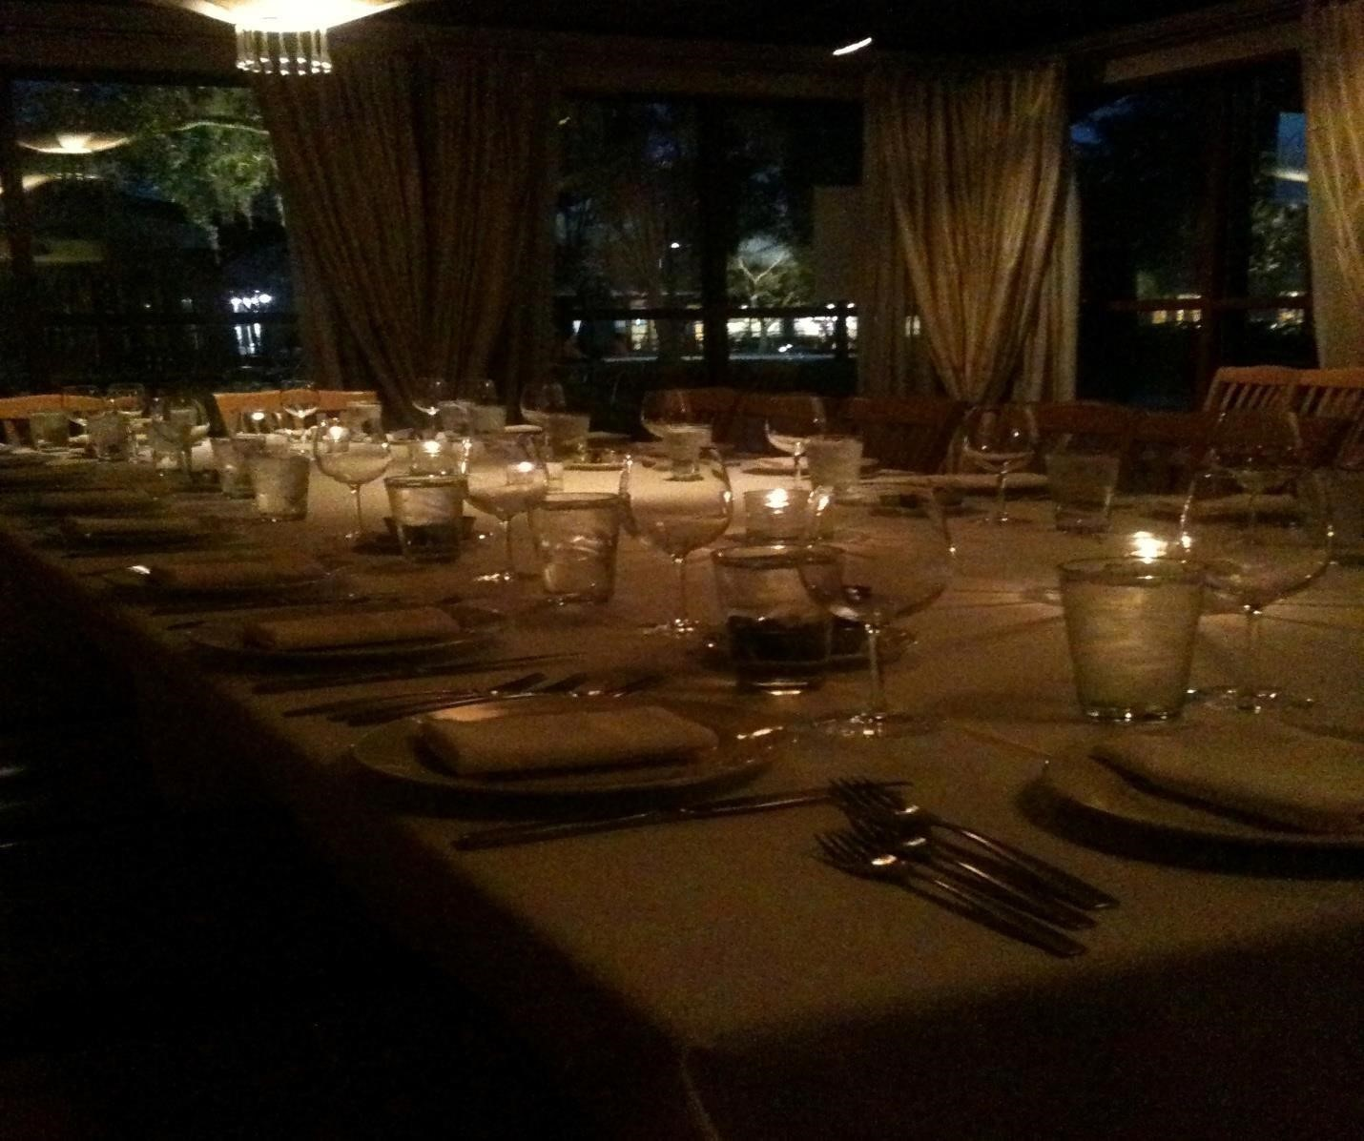

ROOMS AND ACCOMMODATIONS
Off-Premise Catering
We can accommodate up to 150 - 200 people for off-premise events, with a full service option and/or chef catered events. One of our chefs can come to your home to prepare the food as well as assist with party preparations.
Dining
In
The Bordeaux Room…
Accommodates up to 55 people for a sit-down dinner and up to one 100 people for a cocktail party or buffet

*A minimum number of people is required to reserve a private dining room
Semi-private Dining In The Rhone Room...
Accommodates up to 20 people for a sit-down dinner
-Page 2-
HEGE’S STANDARD BUFFET
$58.95/ PERSON

APPETIZERS
(SELECT ANY 6 CANAPES & HORS D’OVUERS pg 5)
*CAN BE DISPLAYED OR PASSED

PLATTERS OR DISPLAYS
(SELECT 2 pg 6)
*ADDITIONAL CHARGE FOR SHELLFISH/ RAWBAR OR SUSHI/ SASHIMI DISPLAYS

CARVING / ACTION STATION
(SELECT 1 from each pg 7)

ENTRES
(SELECT 2 pg 8)

SIDES
(SELECT 3 pg 9)

Desserts (optional)
($ 6.00/ person pg 9)

-Page 3-

LOWCOUNTRY BUFFET $52.95/ PERSON
APPETIZER BUFFET INCLUDED:
ANY 6 HORS D’OVUERS FROM AVAILABLE OPTIONS AS WELL AS PICKLED SHRIMP SALAD WITH FRESH TOMATOES, ONIONS, and OKRA PIMENTO CHEESE WITH GRILLED PITAS

ENTREES (PICK 2)
PULLED PORK BARBEQUE

LOWCOUNTRY BOIL
ANDOUILLE SAUSAGE, SHRIMP, CORN ON THE COBB, RED POTATOES, AND OLD BAY SEASONING

BARBEQUED CHICKEN

SHRIMP & GRITS

SAUTEED SHRIMP, “GEECHIE BOY” GRITS, AND CREAMY TASSO HAM GRAVY

BRAISED BEEF BRISKET

OVER SOUTHERN STEWED TOMATOES

LOWCOUNTRY CRABCAKES

OVER CHEESEY GRITS WITH SHERRIED CRAB CREAM SAUCE

SIDES (PICK 3)

GREEN BEAN CASSEROLE RED CORN PUDDING RICE BRAISED TURNIPS & RUTABEGA HOPIN’ JOHNS SOUTHERN GREEN BEANS STEWED OKRA & TOMATOES COLESLAW COLLARD GREENS SWEET POTATO CASSEROLE MAC & CHEESE CHEESY GRITS SQUASH CASSEROLE ROASTED RED POTATOES

HOUSE MADE CORNBREAD and SOFT ROLLS INCLUDED

DESSERT ($6.00/ PERSON)

KEY LIME PIE BOURBON PECAN PIE BANANA PUDDING PEACH COBBLER

Page 4
PASSED HORS D’OEUVERS

PETITE CRABCAKES WITH RED PEPPER COULIS OR CAJUN REMOULADE
GRILLED CHICKEN SATAYS WITH THAI

PEANUT DIPPING SAUCE
COUNTRY HAM & BRIE BISCUITS ASSORTED MINI GRILLED CHEESE
SANDWICHES WITH SHRIMP, BRIE, and BASIL/PIMENTO CHEESE and BACON/ or BRAISED SHORTRIB and BOURSIN CHEESE

FILO CUPS WITH WILD MUSHROOM, GOAT CHEESE, and RED ONION JAM
TRADITIONAL SPANIKOPITA WITH WILTED

SPINACH, FETA CHEESE, CARAMELIZED ONION, and A PORT WINE REDUCTION
TUNA TARTAR SPOONS WITH SESAME, SOY

CHIVES, and WASABI AIOLI
CRISPY ASIAN SPRING ROLLS ~PORK,

CRAB, SHRIMP, NAPPA CABBAGE, and CARROTS WITH A SWEET CHILI DIPPING SAUCE
BRAISED SHORTRIB CROSTINI WITH
GORGONZOLA CHEESE and SABA?

ENDIVE TIPS WITH SHRIMP, CILANTRO, AVACADO, LIME and RED ONION SALAD
PETTITE TARTS OF ROASTED CORN &

RED PEPPER WITH CHIPOTLE AIOLI
ASIAN SUMMER ROLLS ~BIBB LETTUCE,

CARROTS, RED CABBAGE, SHITAKES, CILANTRO and RICE NOODLES WITH A SWEET SOY DIPPING SAUCE

SESAME SEARED TUNA OVER CORIANDER

RICE CAKE WITH SEAWEED SALAD, SWEET CHILI, and WASABI AIOLI
CHICKEN FAJITA WRAPS ~GRILLED

CHICKEN, ROASTED BELL PEPPERS, CARMELIZED ONIONS, and CHIPOTLE AIOLI
EGGPLANT, TOMATO, and ZUCCHINI TAPENADE WITH HERBED CROUTONS and SHAVED PARMESEAN
ANTIPASTO SKEWERS WITH PROSCUITTO,
TOMATOES, MOZZERELLA, OLIVES, ROASTED RED PEPPERS, and BASALMIC REDUCTION MARINATED
MELON OVER CRISPY
PROSCUITTO WITH FRESH MINT, HONEY and SABA
CRISPY DUCK CONFIT WONTONS WITH ORANGE MARMALADE DIPPING SAUCE SEARED
FILET MIGNON WITH MUSHROOM DUXELLE,

HORSERADISH CREAM, and HERB CROUTON
PROSCUITTO WRAPPED PRAWNS WITH

BASIL and WHOLE GRAIN DIJONAISE
PETTITE QUICHE LORRAINE WITH

APPLEWOOD BACON LARDONS and GRUYERE
CRISPY POPCORN SHRIMP & CALAMARI BASKETS WITH REMOULADE and

COCKTAIL DIPPING SAUCES
SMOKED SALMON CANAPES WITH

TOASTED PUMPERNICKLE, WHOLE GRAIN DIJONAISE and FRESH LEMON
BACON-WRAPPED SCALLOPS

-Page 5-

DISPLAY PLATTERS
TRADITIONAL CRUDITE
~ASSORTED RAW SEASONAL VEGETABLES WITH GREEN GODESS and STRAWBERRY YOGURT WITH HONEY SAUCES
OYSTER and SHELLFISH RAWBAR (ADDITIONAL $14 PER PERSON)

~BLUE POINT OYSTERS ON THE HALF SHELL, JUMBO SHRIMP COCKTAIL,CALAMARI SALAD, MIGONETTE, and COCKTAIL SAUCES
SMOKED SALMON DISPLAY

~CAPERS, RED ONIONS, EGG WHITES, EGG YOLKS, PUMPERNICKLE TOAST POINTS, DIJONAISE, and HONEY SCALLION CREAM CHEESE * OPITIONAL SUBSTITUTION OF A WHOLE POACHED SALMON FOR SMOKED
MARINATED CREMINI MUSHROOMS

~SHERRY VINEGAR, SHAVED PARMESEAN, and HERBS
GRILLED VEGETABLE DISPLAY

~ASSORTED GRILLED and ROASTED SEASONAL VEGETABLES
SUSHI & SASHIMI DISPLAY

~ASSORTED VARIETY OF SUSHI & SASHIMI ACCOMPANIED BY SOY SUACE, WASABI, PICKLED GINGER, SEAWEED SALAD, and CHOPSTICKS
ARTISAN CHEESE SELECTION

~ASSORTED ARTISANAL CHEESES DISPLAYED WITH CANDIED PECANS, GRAPES, and CARR’S CRACKERS
SEASONAL FRUIT DISPLAY

~WITH STRAWBERRY HONEY YOGURT DIPPING SAUCE
TOMATO MOZZERELLA SALAD

~HOUSEMADE MOZZERALLA, OLIVE OIL, BASALMIC and FRESH BASIL
ROASTED RED PEPPER HUMUS
~WITH GRILLED PITA POINTS
UPSCALE SALAD BAR (TO INCLUDE BUT NOT LIMITED TO):

~ASSORTED SALAD GREENS, PUMPERNICKLE CROUTONS, BOILED EGGS, SARDINES, SUNFLOWER SEEDS, ASSORTED RAW VEGETABLES, ASSORTED ROASTED VEGETABLES, SHAVED PARMESEAN, BLEU CHEESE CRUMBLES, SHREDDED SHARP CHEDDAR, LUMP CRAB MEAT, DICED HAM, POACHED POPCORN SHRIMP, RANCH, HOUSE VINAIGRETTE, and BLEU CHEESE DRESSINGS
JUMBO SHRIMP COCKTAIL ~POACHED JUMBO SHRIMP, HOUSEMADE COCKTAIL, AND FRESH LEMON
-Page 6-

CHEF ATTENDED CARVING & ACTION STATIONS

MASHED POTATO MARTINI BAR
(WHIPPED POTATOES SERVED IN A MARTINI GLASS WITH ACCOMPANIMENTS INCLUDING BUT NOT LIMTED TO):
*(ALSO MAY BE SUBSTITUED FOR MAC & CHEESE WITH THE SAME ACCOMPANIMENTS) ~SHARP CHEDDAR CHEESE, BACON, SCALLONS, and SOUR CREAM

LIVE PASTA STATION
PENNE & FARFALLE PASTAS MARINARA SAUCE, ALFREDO SAUCE, GRILLED CHICKEN, SHRIMP, CRAB MEAT, SAUSAGE, TOMATOES, MUSHROOMS, CARAMELIZED ONIONS, BASIL,OLIVES, ROASTED GARLIC, and PARMESEAN CHEESE

CARVING STATION OPTIONS

(ALL CARVING STATIONS TO INCLUDE SOFT ROLLS and HOUSEMADE CORNBREAD) ^{Filet Mignon} WITH HORSERADISH SAUCE and RED WINE JUS
VIRGINIA BAKED HAM WITH APPLE CIDER GLAZE and DIJON MUSTARD
PRIME RIB WITH HORSERADISH SAUCE and AU JUS
HERB ROASTED LEG OF LAMB WITH ROSEMARY THYME JUS and MINT GREMOLATA

STEAMSHIP ROUND (AVAILABLE FOR LARGER GROUPS)

GARLIC RUBBED PORK LOIN WITH PORK JUS and CRANBERRY PECAN CHUTNEY

-Page 7-
ENTRÉE BUFFET OPTIONS

(PICK ONE OF EACH)

SEAFOOD

CRABMEAT STUFFED FLOUNDER
WITH TOMATO BUTTER

BLACKENED MAHI-MAHI
WITH CHEESE GRITS

SEAFOOD NEWBERG
WITH RICE PILAF

SHRIMP SCAMPI
WITH LINGUINI PASTA
LOBSTER RAVIOLI WITH BURRE BLANC SAUCE

SHRIMP & GRITS SEAFOOD PAELLA

WITH CHICKEN, SHRIMP, CALAMARI, and ANDOUIILLE OVER SAFFRON RICE *(ADD LOBSTER FOR AN ADDITIONAL CHARGE)

Page 8

MEAT

BRAISED SHORT RIBS
WITH WILD MUSHROOM GRITS and BRAISING JUS

BRAISED BEEF BRISKET SWEET STEWED TOMATOES

PORK PICATTA
WITH CAVITAPI PASTA and LEMON CAPER SAUCE

ROAST TOP ROUND OF BEEF
WITH PARMESAN POLLENTA and MUSHROOM JUS

CHICKEN COQ AU VIN
WITH PEARL ONIONS and MUSHROOMS

CHICKEN SALTIMBOCCA
WITH VIRGINIA HAM and GRUYERE CHEESE

CHICKEN MARSALA
WITH PENNE PASTA and MARSALA SAUCE

BEEF & PORK BOLOGNESE

WITH BOWTIE PASTA and GARLIC BREAD

PULLED PORK BBQ with soft rolls and assorted sauces

BUFFET SIDE ITEM OPTIONS
(PICK THREE CHOICES)

POTATO CASSEROLE

SQUASH CASSEROLE TRADITIONAL VEGETABLE MEDELEY
(BROCCOLI, CALIFLOWER, and CARROTS)

ROASTED RED BLISS POTATOES SCALLOPED POTATOES GARLIC MASHED RUSSET POTATOES
RICE PILAF
GREEN BEAN ALMONDINE GRILLED ASPARAGUS ROASTED ROOT VEGETABLES
(TURNIPS, RUTEBEGA, AND BRUSSEL SPROUTS)

SWEET SOUTHERN MAC & CHEESE
STEWED TOMATOES
WITH OKRA and ONIONS

HOUSE MADE COLESLAW TOMATO and CUCUMBER SALAD BOWTIE PASTA SALAD
(GERMAN, SOUTHERN, OR MEDITERAINIAN STYLE)

CANDIED BABY CARROTS FRESH BABY GREEN SALAD
WITH ASSORTED ACCOMPANIMENTS

COLLARD GREENS RED RICE

Page 9

DESSERT (PICK 2) (ADDITIONAL CHARGE $6.00/ PERSON)

KEY LIME PIE
WITH RASPBERRY COULIE, CRÈME ANGLAISE, and FRESH SEASONAL BERRIES

WARM CHOCOLATE MOLTEN CAKE

PEANUT BUTTER GANACHE, CHOCOLATE SAUCE, RAPSBERRIES, and VANILLA BEAN ICE CREAM

BOURBON PECAN PIE
WITH HOUSE MADE CARAMEL SAUCE AND WHIPPED CREAM

SEASONAL BREAD PUDDING
SERVED WITH RUM SAUCE AND VANILLA BEAN ICE CREAM

Page 10

HEGE’S PLATED DINNER PARTIES $62.00/ PERSON

(HOSTED IN THE RHONE OR BOURDEAUX ROOMS)

(RENTAL FEE MAY APPLY)
*OPTIONAL APPETIZER COURSE AVAILABLE FOR $14.95/PERSON BASED ON MENU, SEASONABILITY, and CHEF/ CLIENT SELECTIONS
1ST COURSE (PICK 2)
CHARLESTON SHE CRAB SOUP WITH SHERRY and LUMP CRABMEAT SOUP DU JOUR BETTY HEGE’S HOUSE SALAD TRADITIONAL CAESAR SALAD SEASONAL BABY GREEN SALAD

2ND COURSE (PICK 3)

BACON-WRAPPED 8oz. FILET MIGNON
WITH GARLIC WHIPPED POTATOES, GRILLED ASPARAGUS, DANISH BLEU CHEESE, and RED WINE JUS

HERB ROASTED AUSTRALIAN RACK OF LAMB

WITH ROASTED RED POTATOES, CARAMELIZED ONIONS, HARICOT VERT, CREMINI MUSHROOMS, and ROSEMARY THYME AU JUS

GRILLED PRESTIGE FARMS CHICKEN BREAST
WITH AROMATIC JASMINE RICE, GARLIC BROCCOLINI, and CHICKEN HERB JUS

CIDER BRINED 10oz. BONE-IN PORK CHOPS
WITH SWEET POTATO PUREE, PECAN BUTTERED GREEN BEANS, CHARRED APPLES, and APPLE CIDER GASTRIQUE

LOBSTER RAVIOLIS

SERVED WITH ½ COLD WATER LOBSTER TAIL, GRILLED SHRIMP, ROASTED VEGETABLES, and BEURRE BLANC SAUCE

PAN SEARED LOCAL GROUPER
ROASTED FINGERLING POTATOES, MELTED LEEKS, HARICOT VERT, LUMP CRABMEAT, and LOBSTER CREAM SAUCE

GRILLED MAHI-MAHI
WITH RICE PILAF, GARLIC BROCOLINI, PRESERVED LEMONS, LEMON THYME BUTTER, and BASALMIC REDUCTION

OVEN ROASTED CHILEAN SEA BASS
SEE CHEF FOR SEASONAL PLATE SETUP and ACCOMPANIMENTS

PAN-SEARED ALASKAN HALIBUT

(AVAILABLE APRIL – NOVEMBER ONLY)
WITH WHITE BEAN CASSOLLE, WILTED SPINACH, CRISPY COUNTRY HAM, and “HOLY SMOKE” INFUSED OLIVE OIL
-Page 11

Courtyard Party Space
